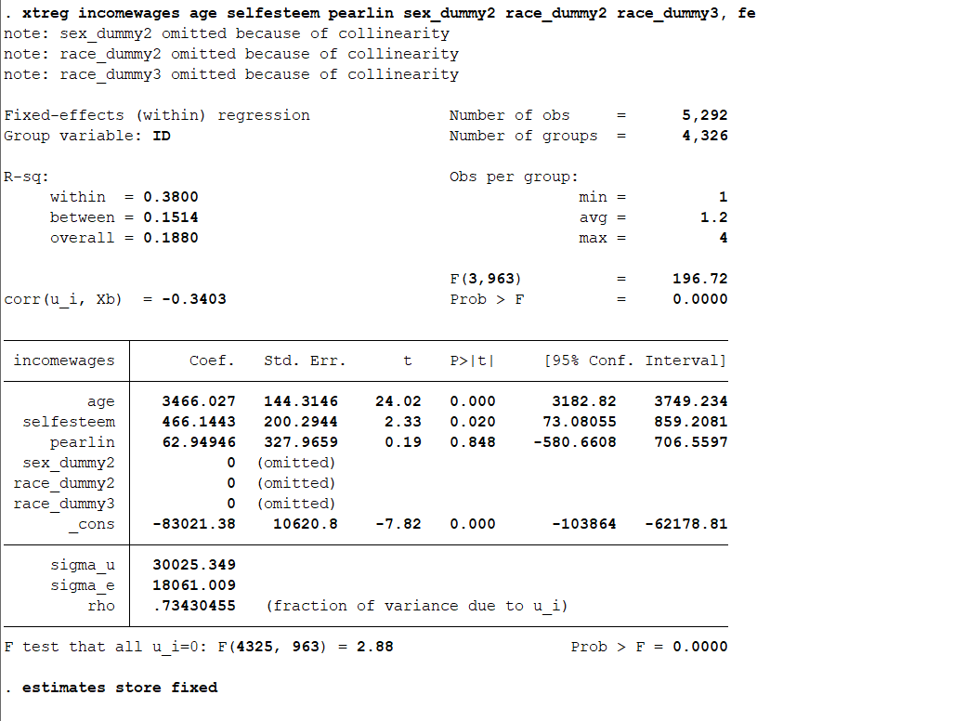

**Fixed Effects Model**

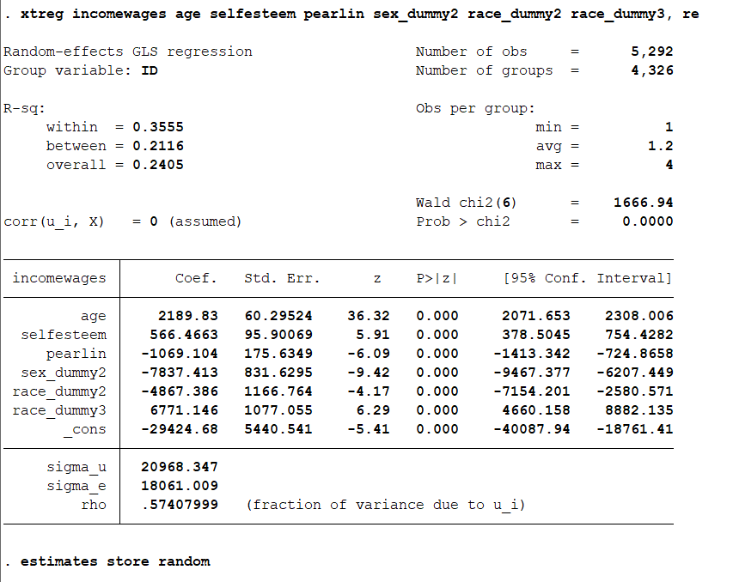

**Random Effect Model**

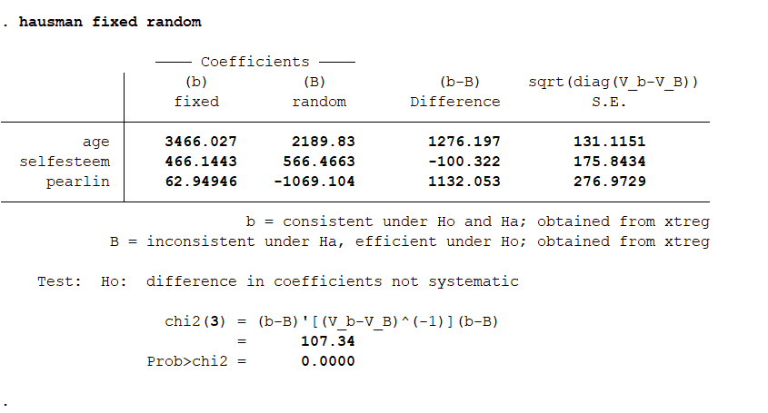

**Hausman Test: p<0.05, hence Fixed Effects Model is preferred**

Hausman test is used to detect if there is any potential endogeneity in the model (endogeneity refers to the case where explanatory variables are correlated with error term or fixed effects). In our case, p-value associated with the Hausman test was less than 0.05 and hence I was bound to believe that the individual effects are systematic. Therefore, I prefer a fixed effects model over a random effects model for our analysis. This also shows potential endogeneity. To mitigate that, I ran an Arellano-Bond difference GMM model and then alternatively a system GMM model. The difference GMM could not display results due to high collinearity among the variables and the system GMM results were incomplete (associated t-statistic and p-value for individual variables were not shown). I assume that the incompleteness of data (high number of missing values) and lower number of variables might have contributed to that.

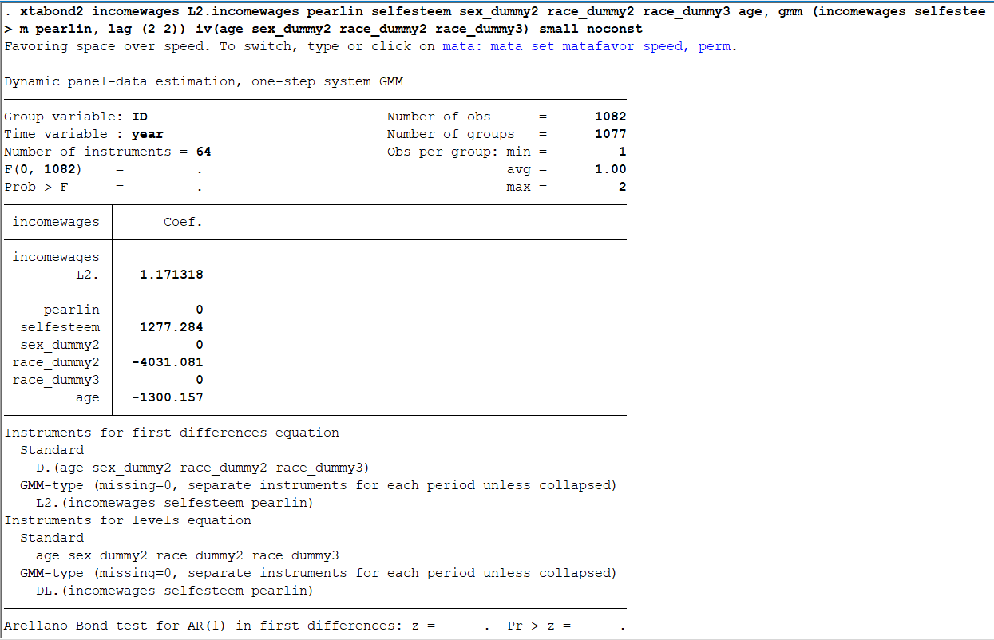

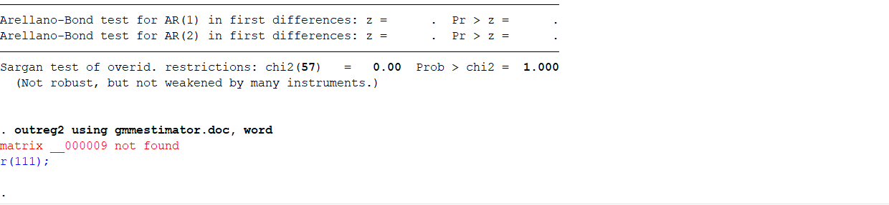

**System GMM**

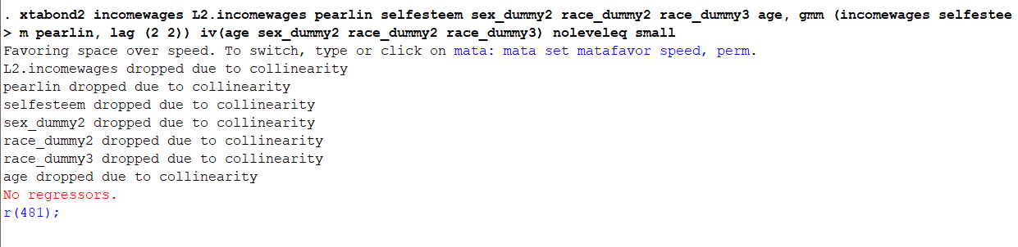

**Difference GMM**